**Experiment:1** Create a simple cloud software application for Flight Reservation System using any Cloud Service Provider to demonstrate SaaS include the necessary fields such as one way, round trip, From, to, Departure, Departure, Travelers & Class, Fare Type, International and Domestic Flights etc.

**AIM:**

To create a simple cloud software application for flight reservation system using any cloud service provider to demonstrate saas.

**PROCEDURE:**

**step1:** Go to zoho.com**.**

**step 2:** Log into the zoho.com.

**step 3:** Select one application step.

**step4:** Enter application name as flight reservation system.

**step 5:** Created new application flight reservation system.

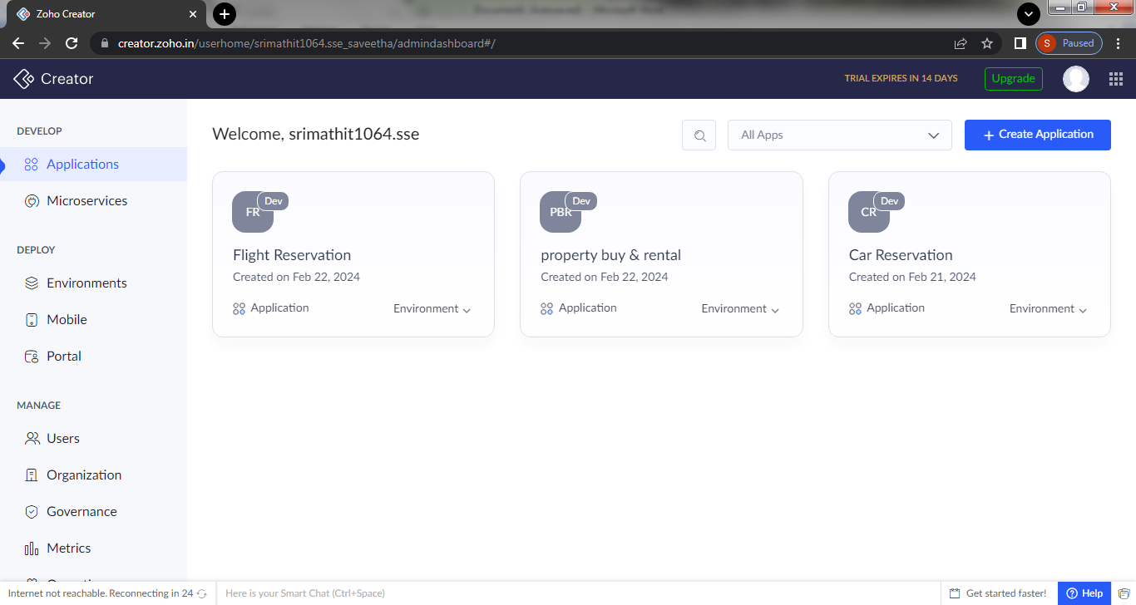

**step 6: Create login form**

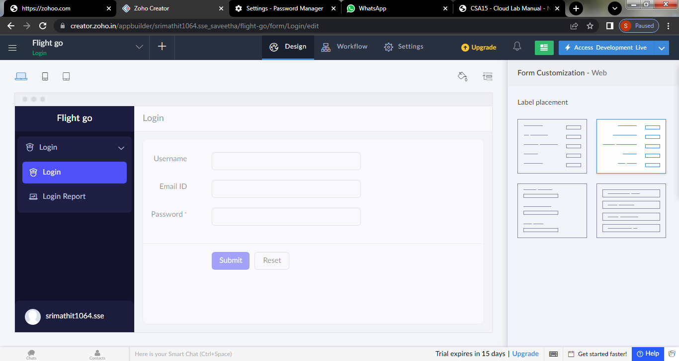

Step:7 :Create a second form for personal details

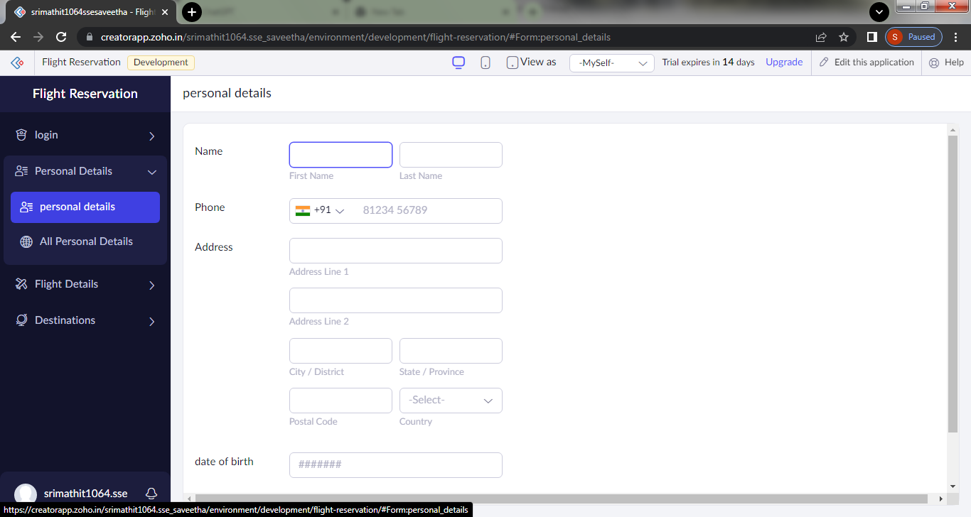

Step 8: create third form to get the details of flight

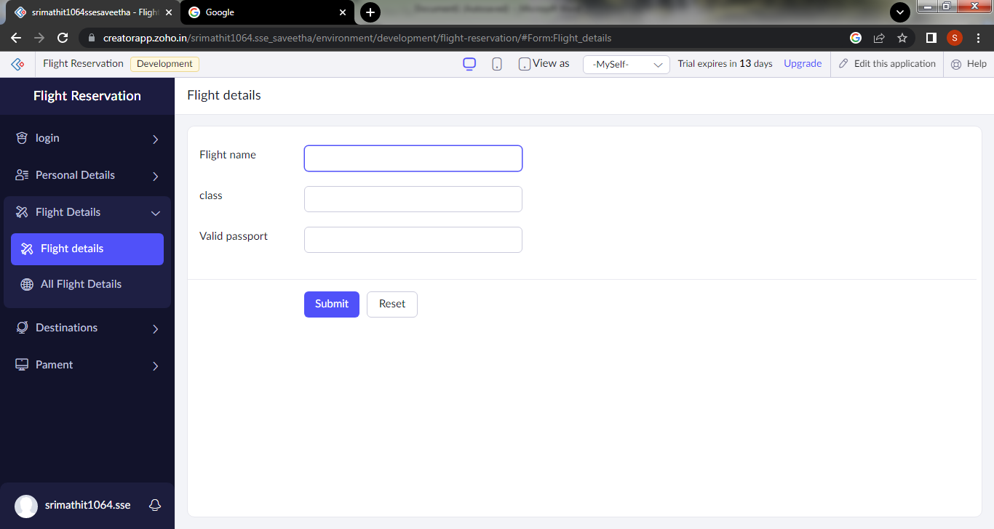

Step 9:create a form to choose Destination

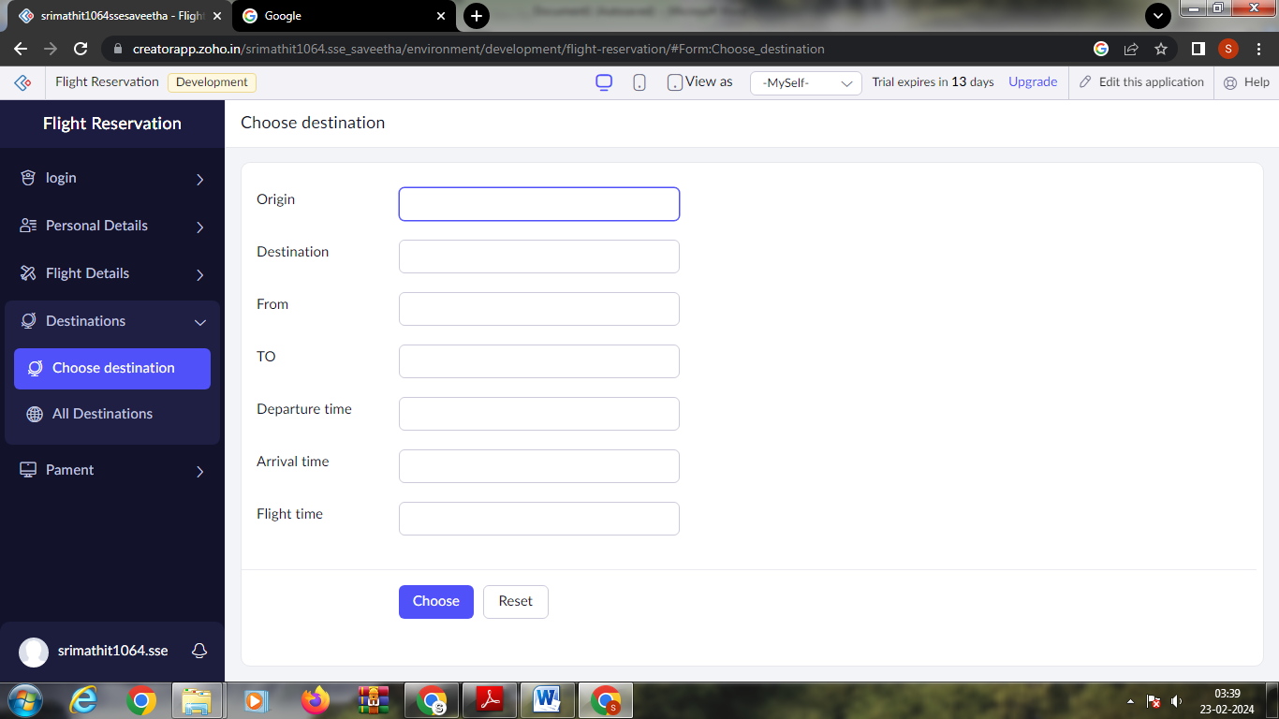

Step 10:create payment form

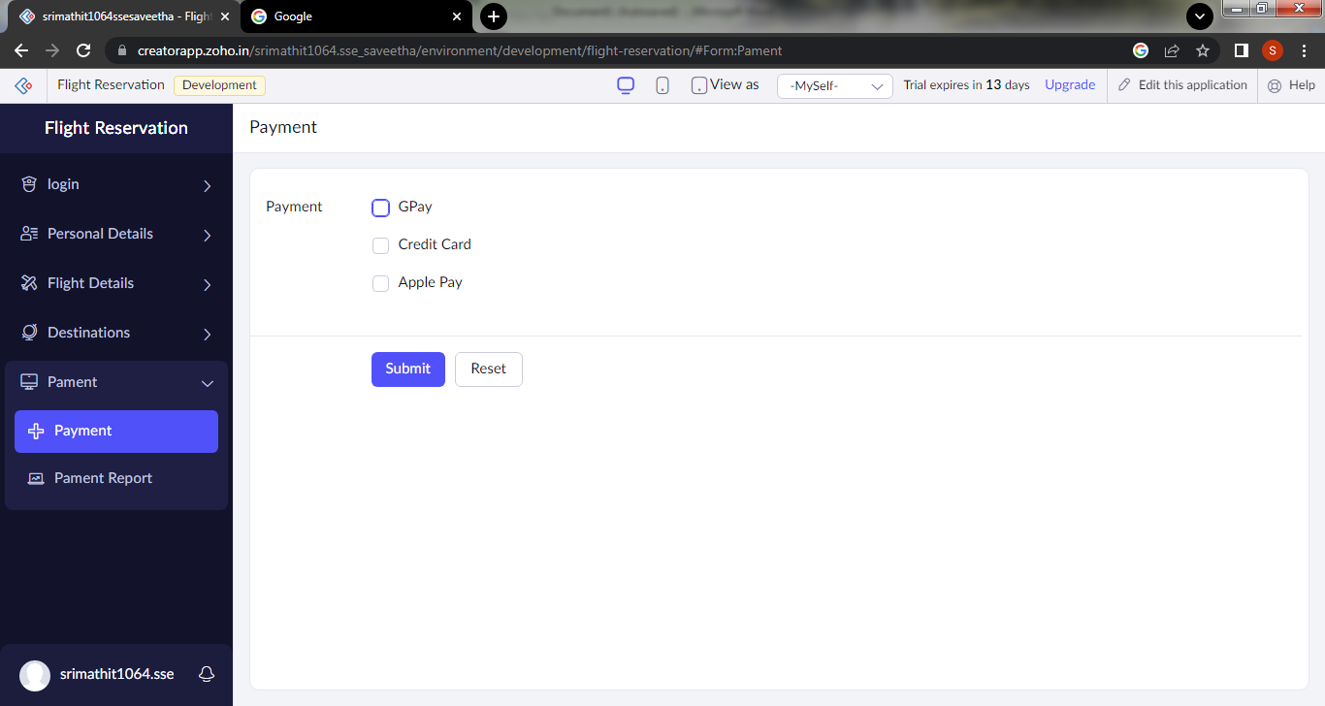

Step 11:click on the access development to see the live results

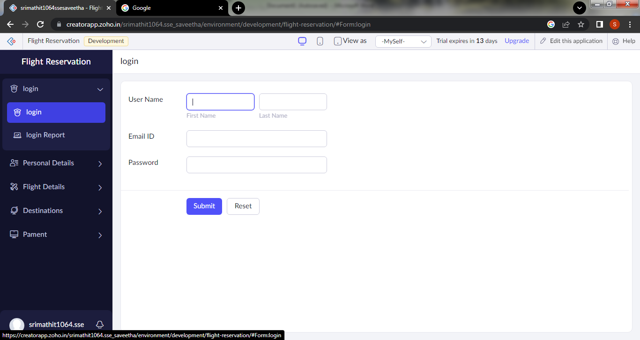

Step 12: click on the login report to see the user data

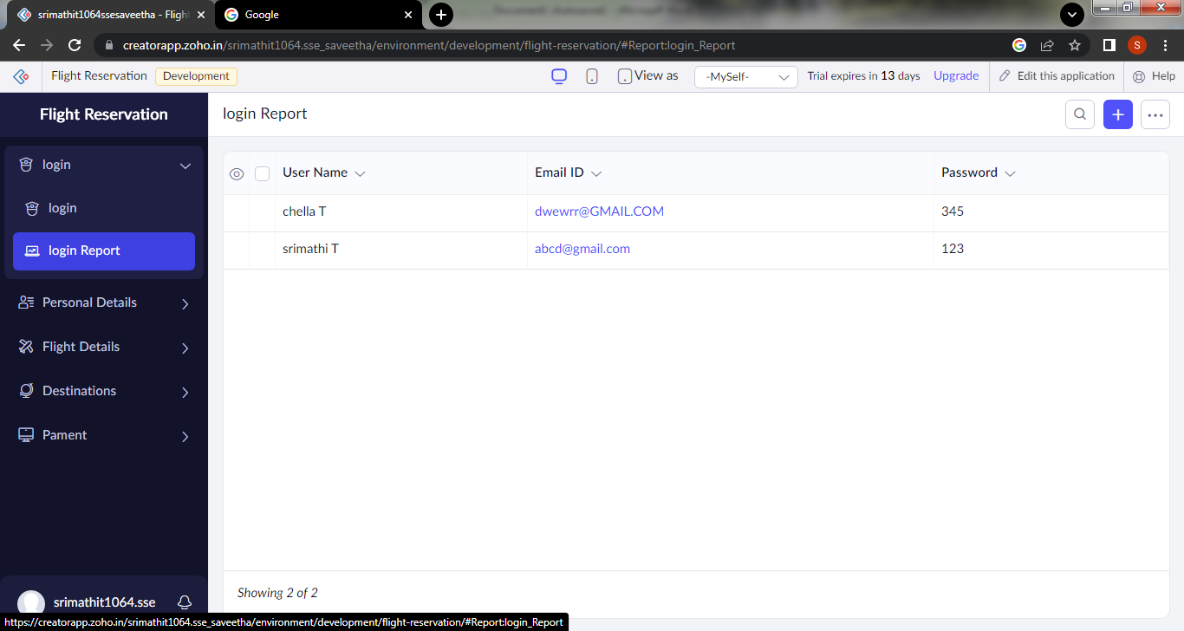

Step 13: click on the mobile icon to see mobile output

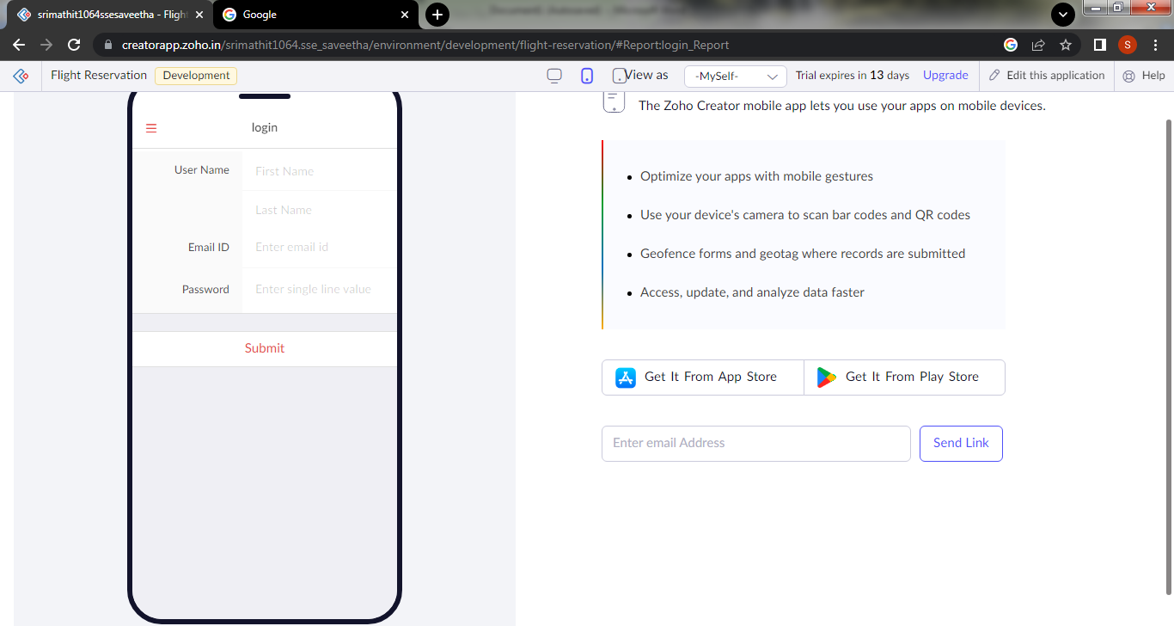

Step 14:click on the tablet view to see the tablet output

